COMP 342: Data Communications and Networking
Spring 2026
Project 2 HTTP Client and Server
Date Released: 04/10/2026
Instructions: for a total of 100 points build a simple web client and a web server. For this project, use BufferedReader and PrintWriter classes to communicate over the socket.
Part 1: The HTTPClient:
The web client should be able to interface with any web server including your web server using HTTP 1.1.
- It takes as input:
  - the server IP address or host name
  - the file path name (optional)
- It connects to the web server with the specified address and requests the specified file. It performs the following
  - build the HTTP request manually
  - receive the HTTP response
  - parse the HTTP response
  - save the file retrieved in the local directory (client_folder)
- The client needs to use sockets to connect to the server.
- Assume a TCP port of 80.

Part 2: The HTTPServer:
The web server should be able to communicate with a web browser and the web client created in part 1.
- It does not take any command line arguments
- It listens to connections from the client. It supports the following requests:
  - A request without a filename: it sends a response with index.html in it.
  - A request with a simple filename: it sends the file requested
  - A request with a path to a file: it parses the path and sends the file requested. The server has a constant variable that stores the path to the current directory (server_folder).
- Once connected, the server needs to perform the following:
  - Receive and parse the HTTP request to determine the file requested
  - Build the HTTP response manually including the correct file
  - Send the HTTP response to the client
- The server can only service one client.
- The sever needs to use sockets to connect to the client.
- Assume a TCP port of 80.

Evaluation Scenario:
The HTTPClient and HTTPServer will be evaluated with the following tasks:
- Test1 – HTTPClient interacts with HTTPServer
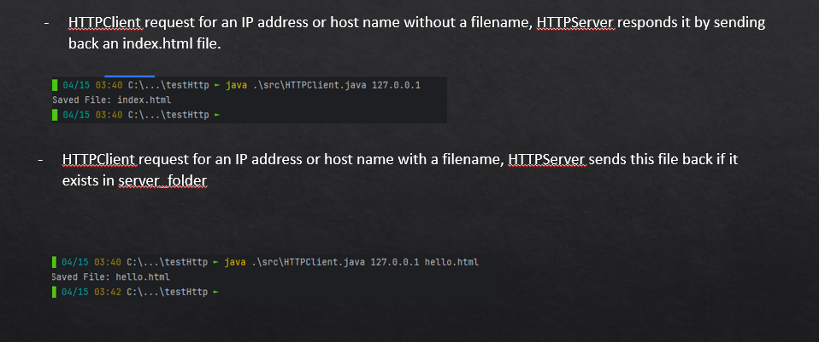
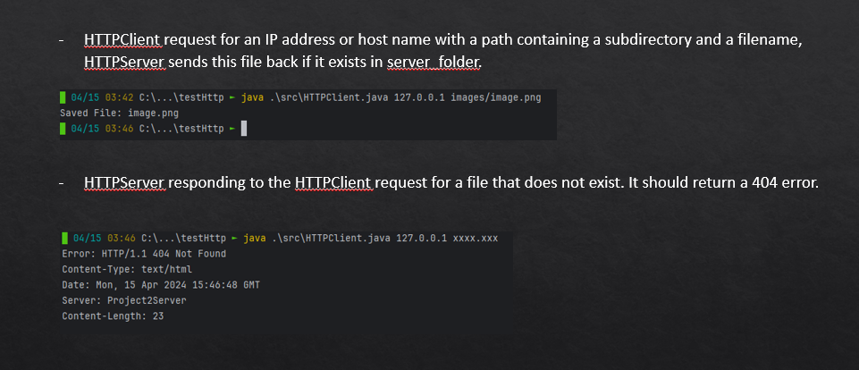

- Test2 – HTTPServer responds to a web browser request:
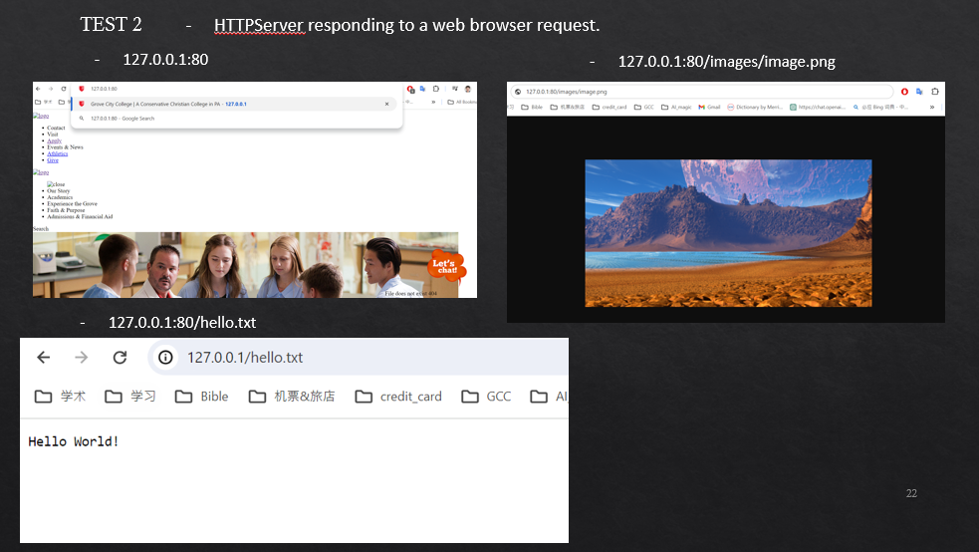

- Test3 – The HTTPClient requesting a page from a web server on the Internet, and it saves the response file as index.html in client_folder
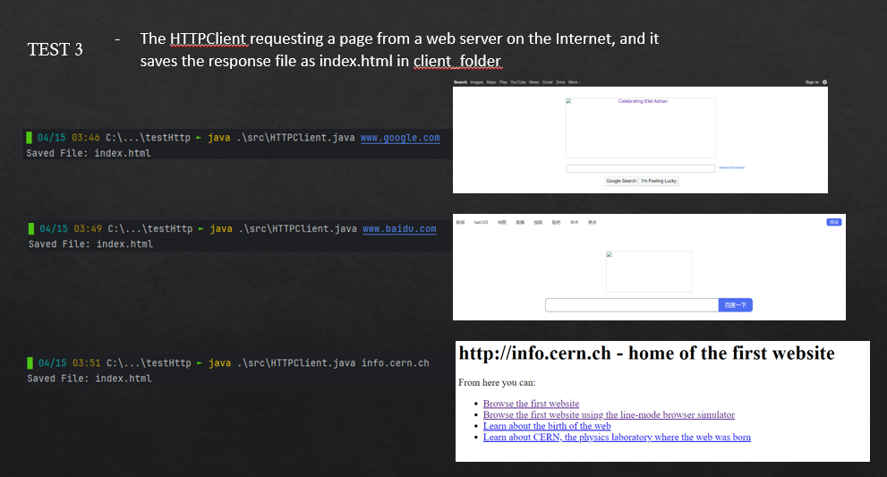

Project Deliverables:
For this project, each team needs to deliver two java source files: one for the HTTPClient and one for the HTTPServer. Also, please make and submit a short video clip demonstrating the evaluation results of your code.

Rubric: To receive credit, submit a .zip file via mygcc containing all of your code.

Points will be awarded based on the following:
The HTTPClient requesting a page from a web server on the Internet | 20
The HTTPClient requesting a page from the HTTPServer. | 20
HTTPServer responding to a web browser (Internet Explorer) request. | 30
HTTPServer responding to the HTTPClient request for an IP address or host name without a filename. | 5
HTTPServer responding to the HTTPClient request for an IP address or host name with a filename. | 5
HTTPServer responding to the HTTPClient request for an IP address or host name with a path containing a subdirectory and a filename. | 5
HTTPServer responding to the HTTPClient request for a file that does not exist. It should return a 404 error. | 5
Make a video clip to demonstrate the results for evaluation. Your video should be alike the uploaded one showing the tests 1-3. | 10

Your code must execute in IntelliJ or Eclipse IDE. Also, if your code crashes, no partial credit will be given

Extensions will not be granted for technology-related issues. Leave yourself enough time to complete the assignment, submit the assignment using mygcc, and contact the instructor if you run into problems.

Project Policies:
- Assignments must be submitted electronically via my.gcc. Be sure to upload your files correctly the first time.
- This project is a group project. Every student needs to work as a part of a 2-person team. If you cannot find a team to work with, contact Dr. Zhang and he will assign you a team. Students are expected to stay in the same team used for Project 1.
- Students are expected to keep the same team for the whole semester.
Academic Integrity Policy:
- Each team is expected to work on its own. Members of each team can work together, discuss ideas, look at each other’s code, and share files among each other.
- Students belonging to different teams should not discuss, share code that directly bears on this project, or look at each other’s code. Any instances of this will be considered a violation of the academic integrity policy of this course and will be reported to the SFRC committee.
- Use or possession of past solutions and similar solutions from online resources is strictly prohibited and is considered a violation of the academic integrity of this course.
- You may use online resources to look up how to use a function, but you may not copy code from online resources. Any copied code (whether cited or not) is considered a violation of the academic integrity policy of this course.

